Person(s) responsible for updating the policy: | Ruth Heyes
Date Approved | 20 May 2024
Date of next review | 20 May 2025
Status | Approved
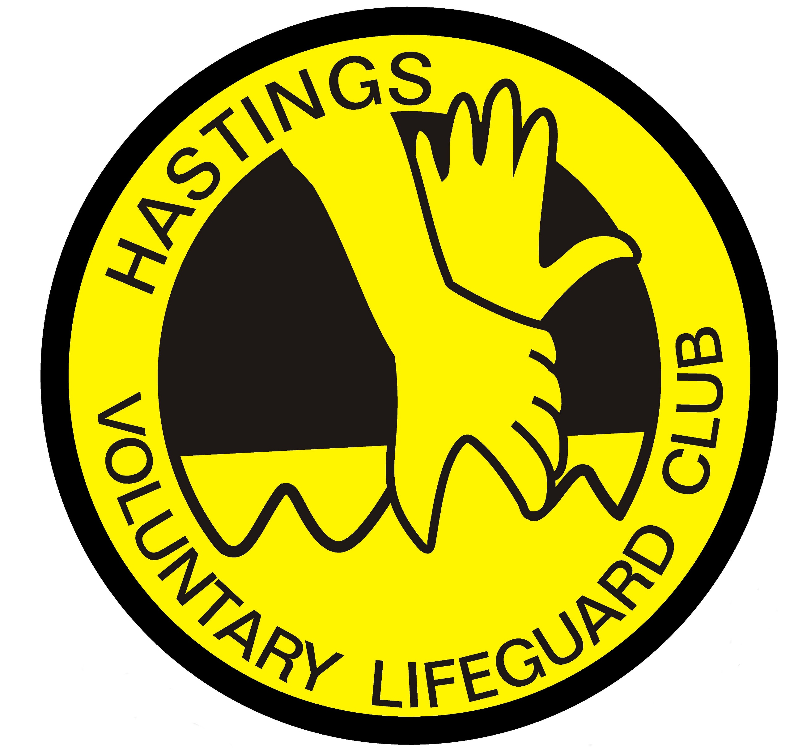
Hastings & St.Leonards Voluntary Lifeguard Club
Adult at Risk Safeguarding Policy
1st June 2024
What to do if you feel unsafe or want to report a safeguarding concern
As a Club we want to ensure that we provide you with a safe and welcoming environment where you feel you are respected and valued. If you feel unsafe or have any concerns then you should contact one of the Designated Safeguarding Leads (DSL) in the organisation (see section 6.0) or confide in a person that you trust (parent, coach or friend). These individuals can contact the DSL on your behalf. We are here to support you.
All information regarding RLSS UK safeguarding can be found on the RLSS UK Website. As a Club will ensure that all safeguarding concerns and allegations are dealt with in accordance with the RLSS National Policy and Practices.
- Policy statement

  - RLSS UK is committed to ensuring that adults, especially those at risk who participate in its activities including lifesaving, lifeguarding, community awards, education, sports, competitions and any other events have a safe, positive and enjoyable experience. RLSS UK recognises that through some of its activities, especially those requiring life support or casualty care, that any adult may, at any point become at risk.

All groups of people whatever their age, gender, language, disability, race, religion or belief, sexual orientation, socio-economic status and culture have the right to protection from abuse and to be treated fairly. Everyone involved with an adult who may be at risk is uniquely placed to recognise and respond to abuse and poor practice across RLSS UK.

  - RLSS UK recognises that the Care Act (2014) has created a legal framework for how Local Authorities, other agencies and organisations should work together to protect adults at risk of abuse, harm or neglect. In line with the Act RLSS UK also recognises that safeguarding individuals requires multi agency responsibility and partnership work.

  - Making Safeguarding Personal (MSP) will form an essential part of this policy and the work that is undertaken by those in RLSS UK. Our aim is to empower people to speak out, with actions and outcomes tailored to the needs of the individual. All of the decisions made and the action taken will be in the best interests of the adult at risk.

  - Our Club recognises that the Care Act (2014) has created a legal framework for how Local Authorities, other agencies and organisations should work together to protect adults at risk of abuse, harm or neglect. In line with the Act our Club also recognises that safeguarding individuals requires multi agency responsibility and partnership work.

  - Making Safeguarding Personal (MSP) will form an essential part of this policy and the work that is undertaken by those at the Club. Our aim is to empower people to speak out, with actions and outcomes tailored to the needs of the individual. All of the decisions made and the action taken will be in the best interests of the adult at risk.
  - This Policy should be read in conjunction with the RLSS UK working practices and procedures at www.hastingslifeguards.org.uk

- Application

  - This policy applies to all of those who occupy positions of responsibility, who work, volunteer or come into contact with children as part of their role within the Club. The policy and associated procedures will be promoted to all staff, volunteers and participants as part of their induction process at the Club.

  - [Insert Club Name] will ensure that a copy this policy is sent to all members of staff and volunteers and they will be required, after a reasonable time, to signify to the Club DSL that they have received it and are conversant with the content.

  - This policy will be made available to all of those taking part in activities in the Club.

3.0. Adult protection statement
  - As a Club we recognise that we have a moral and statutory responsibility to safeguard and promote the welfare of all adults. To achieve this, we will provide a safe environment where everyone is respected and valued. We will all be alert to the signs of abuse and neglect and follow our procedures to ensure that adults at risk receive effective support, protection and justice.
  - RLSS UK has based the National and this Club policy around the six principles of Adult Protection. These principles provide a framework that will assist staff and volunteers in supporting and protecting individuals from the risk of abuse, harm or neglect. The principles are;

- Protection: Ensuring that all adults at risk, regardless of age, disability, gender, racial heritage, religious belief, sexual orientation or identity, have the right to equal protection from all types of harm or abuse.
- Empowerment: Valuing individuals, listening to and respecting all adults.
- Prevention: Adopting best practice and providing safeguarding policies and procedures for all RLSS UK staff and volunteers to follow.
- Partnership: Sharing information about concerns with the appropriate agencies, in a confidential manner.
- Accountability: Providing effective management for staff, contractors and volunteers through supervision, support and training.
- Proportionality: Acting in collaboration with individuals to take a proportionate response to risk.

  - As a Club we will offer a person centred approach and the organisation expect clubs to adhere to local partnership safeguarding practices.

  - This policy also includes the Club’s stance with regards to Modern Slavery. Modern Slavery takes many forms including forced and compulsory labour, slavery, servitude and human trafficking. It is the violation of human rights and the RLSS UK has a zero-tolerance approach to Modern Slavery. We will also take any concerns in this area seriously.

  - The Club will consider any request for this policy to be made available in an alternative format or language.

- Definitions in Adult Safeguarding

To assist in understanding this policy a number of key definitions need to be explained:

Adult - An adult is anyone aged 18 or over.
Adult at risk - An adult who has needs for care and support (whether or not the authority is meeting any of those needs), and is experiencing, or is at risk of, abuse or neglect; and as a result of those needs is unable to protect themselves against the abuse or neglect or the risk of it.
Whilst not an exhaustive list, an adult who may be at risk of harm or abuse may include:
- An older person,
- A person with a physical disability, a learning difficulty or a sensory impairment,
- Someone with mental health needs, including dementia or a personality disorder,
- A person with a long-term health condition,
- Someone who is substance dependant to the extent that it affects their ability to manage day to day living. In such cases the capacity of an individual to make informed decisions (due to mental capacity-see Section 11.0) may alter on a regular basis

People with care and support needs are not inherently vulnerable, but they may become vulnerable to the risk of abuse, harm or neglect at any point due to:
- Physical or mental ill-health,
- Becoming disabled,
- Getting older,
- Not having support networks, appropriate accommodation or financial stability,
- Being socially isolated.
Adult safeguarding - is protecting a person’s right to live in safety, free from abuse, harm and neglect.
Harm- The ill-treatment or impairment of the health or development of an individual, including impairment suffered from seeing or hearing the ill-treatment of another.
Concern - Any situation when there is information that an Adult at risk has been harmed, or is at risk of being harmed or abused, by their own or someone else’s behaviour.
Safeguarding Allegation - This will apply where a person in connection with their employment, membership or volunteering position within the Club has:
- Behaved in a way that has harmed/may have harmed an adult at risk,
- Possibly committed a criminal offence against or related to an adult at risk,
- Behaved towards an adult at risk in a way that indicates he or she may pose a risk of harm to them; or
- Behaved or may have behaved in a way that indicates they may not be suitable to work with adults at risk.
Capacity (see section 8.0) - refers to the ability of an individual to make a decision at a particular time. The starting assumption must always be that a person has the capacity to make a decision unless it can be established that they lack capacity (Mental Capacity Act 2005).
Please see Appendix A for types of abuse
Poor practice:
Sometimes, concerns may relate to poor practice (see RLSS UK’s Low Level Concern Policy for more details), where an adult’s or another young person’s behaviour is inappropriate and may be causing distress to a child or young person. In the application of this policy, poor practice includes any behaviour which contravenes the principles of this document or RLSS UK Code of Conduct. Where poor practice is serious or repeated this could also constitute abuse and should be reported immediately.
It is essential all staff and volunteers, particularly coaches understand and maintain professional boundaries when working with children.
- Our Clubs Commitment to Adults at Risk

  - The people that work, volunteer and represent our Club recognise that ability and disability can change over time, such that some adults may be additionally vulnerable to abuse, for example those who have a dependency on others or have different communication needs. They also recognise that an adult with disability may or may not identify themselves or be identified as an adult ‘at risk’.

  - We expect all those who occupy positions of responsibility, who work, volunteer or come into contact with adults who may be at risk to;

- protect them from abuse whilst they are participating in any activity associated with the Club;
- promote and prioritise their safety and wellbeing;
- create a culture where all adults at risk, parents, guardians, advocates, carers and others who may have a concern are encouraged to report their concerns about the abuse that has happened to them or others;
- have a clear understanding of their duties and responsibilities to safeguard adults at risk;
- take appropriate action in the event of incidents/concerns of abuse and support the individual/s who raise or disclose the concern.

5.3 Our Club will support all adults at risk by:

- allowing them to participate in activities in a way that is appropriate for their ability.
- ensuring that they are coached and trained by appropriately qualified staff or volunteers who have been competently trained.
- encouraging self-esteem and self-assertiveness, whilst not condoning aggression or bullying;
- promoting a caring, safe and positive environment s through the training of officials;
- recognising that an adult who is abused or who witnesses violence may feel helpless and humiliated, may blame themselves, and find it difficult to develop and maintain a sense of self-worth.
- offering details of helplines, counselling or other avenues of external support;
- liaising and working together with all other partnerships, support services and those agencies involved in adult safeguarding;
- accessing and utilising the necessary resources and guidance to identify adults requiring mental health support;
- reassuring victims that they are being taken seriously and that they will be supported and kept safe;
- ensuring that they know there are adults in each of the Clubs who they can approach if they are worried or feel unsafe;
- reinforcing good safeguarding practice to equip all adults with the skills they need to stay safe from harm and to know to whom they should turn for help.

- Club Safeguarding Roles

6.1 The details and contacts of the Club/District Safeguarding representatives are;

Role | Name | Email | Telephone
Club DSL | Ruth Heyes heyes.ruth@gmail.com 07973 961425
Branch DSL | Doug Simmonds doug.simmonds@btinternet.com 07889379964

- Reporting a Concern

  - All Club staff, volunteers and members have a responsibility to be alert to the fact that adults at risk may have been abused and that they MUST report safeguarding concerns.

  - By following the four simple safeguarding principles of Recognise, React, Record and Report, those affiliated to the Club can keep those adults who may be at risk of abuse safe from harm.

7.3 Recognise
7.3.1 We will be alert for the signs and indicators that adults at risk who interact or engage with the Club may be suffering abuse either within the organisation or in external environments (i.e. home, school etc). We should remember that children may be abused by other adults and young people as well as by adults.
Indicators that a child may be being abused may include the following:
- Unexplained or suspicious injuries such as bruising, cuts or burns, particularly if situated on a part of the body not normally prone to such injuries.
- An injury for which the explanation seems inconsistent.
- The adult describes what appears to be an abusive act involving him/her.
- Someone else (a young person or adult) expresses concern about the welfare of another.
- Unexplained changes in behaviour (e.g., becoming very quiet, withdrawn or displaying sudden outbursts of temper),
- Sudden or unusual distrust of adults, particularly those with whom a close relationship would normally be expected,
- Having difficulty in making friends.
- Displaying variations in eating patterns including overeating or loss of appetite; or a sudden weight change.
7.3.2 It should be recognised that this list is not exhaustive and the presence of one or more of the indicators is not proof that abuse is actually taking place.
7.3.3 It is important to note that not be that all adults at risk are able to express themselves verbally. Communication difficulties, language barriers or specific disabilities may mean that it is hard for them to complain or to be understood. In some instances children particularly those with disability may need to be supported by an advocate.
7.3.4 We also recognise that many adults may be have experienced trauma in their past (Adverse Childhood Experiences) which could be affecting their behaviour and outcomes in life. We recognise that we have an important part to play in providing a safe environment for those who have suffered from such trauma and we will provide help and support through signposting them to specialist help and support.
7.4 React
7.4.1 It is always difficult to hear about or witness harm or abuse experienced by an individual. The following points will be helpful for both you and the adult concerned should they choose to disclose abuse to you:
- Stay calm.
- Listen carefully to what is said and try not to interrupt.
- Find an appropriate point early on to explain that it is likely that the information will need to be shared with others – do not promise to keep secrets.
- Allow them to continue at their own pace.
- Ask questions for clarification only and avoid asking questions that suggest an answer (leading questions).
- Reassure them that they are not to blame and have done the right thing in telling you. If the concern is serious explain that you will need to get support from other trained people to help keep the them safe. This must be shared even if the child doesn’t want you to tell anyone else.
- Tell them what you will do next and with whom the information will be shared. If they are adamant that they do not wish the information to be shared, explain that you will have to tell the DSL (or Deputy) and that it will be discussed further with them.
- Be aware of the possibility of forensic evidence if the disclosure relates to a recent incident of physical harm or injury and try to protect any supporting materials e.g. clothing.
- Seek medical attention were appropriate.
- Report the disclosure to the Club/Branch DSL (or Deputy) at the earliest opportunity.
- Don’t confront the alleged abuser.
7.4.2 Where the concern or allegation is about a member of staff, member or a volunteer, this must like all other instances be reported to the Designated Safeguarding Lead (DSL) or Deputy. If the DSL or Deputy considers the circumstances to relate to a ‘Safeguarding Allegation’, they must report the incident to the Local Authority. Depending on the circumstances it may also be necessary to inform the police.
7.5 Record
7.5.1 All records must be accurate and comprehensive. Wherever possible you should use the RLSS UK reporting form and ensure you also notify the Club/Branch DSL or Deputy DSL.
7.5.2 You must record all potential safeguarding issues including low level concerns. Such concerns may be an indicator of more complex harm is occurring and could identify patterns of abuse.
7.5.3 All records must:
- Be made as soon as possible after the event/concern is raised.
- Contain the date, time, people present, anything said (verbatim if possible).
- Detail the behaviour and demeanour of the person disclosing the safeguarding issue.
- Detail any action you have taken (for example how you have reduced risk or whether you have referred the matter to a Designated Safeguarding Lead or Deputy).
- Be a factual account of what has happened.
- Adhere to confidentiality (only share with appropriate people).
7.5.4 Do not record any opinion about what has happened. You are not there to judge or ascertain whether what you are being told is correct.
7.6 Report
Remember you have a clear responsibility to report the concerns that have been raised with you immediately. Any delay in reporting could potentially cause more harm.
7.6.1 In the first instance you must report concerns that you have to the Club/Branch DSL (or Deputy) on the telephone, in person or where appropriate, via email. Where you use email, please ensure that you follow this up with a telephone call.
7.6.2 If a member of staff or volunteer is working away from premises controlled by the Club for a partner organisation, then the Safeguarding Policy of that organisation should be followed. Concerns must also still be reported to the Club/Branch DSL (or Deputy), and they will in turn offer any assistance to the other organisation.

7.6.3 Where the concern or allegation relates to the Club/Branch DSL then the matter should be referred to the RLSS HQ DSL or their Deputy.
7.6.4 Safeguarding concerns MUST be reported immediately (or where this is not possible at the earliest opportunity) so that the report can be assessed, and action taken to protect the person involved. If any person is at immediate risk of harm or requires medical attention, then the emergency services should be contacted immediately by telephoning 999.
7.6.5 Where you are unable to contact a DSL, advice can be sought from statutory agencies or by calling or emailing the following;
- East Sussex County Council Children Service Tel: 01424 724120
- Local Police - Telephone 101 for non-emergency referrals and 999 for emergency response.

- Consent

  - The issue of capacity is complex. Under the Mental Capacity Act (2005), adults should be assumed to have capacity to make decisions about their own life. As such Club staff and volunteers will seek to work proactively with individuals and involve them wherever possible in decisions about their care and safety.

  - Where there is a safeguarding concern, a referral to statutory services will be the correct course of action, and the Club staff member or volunteer will endeavour to speak to the individual and obtain their permission to refer to the Police, Adult Social Care or other appropriate services. To obtain consent the individual should discuss the nature of the concern with the individual (an advocate or carer may assist in this process), the reasons why a referral is appropriate and explain the potential outcomes. This will enable the person to make an informed decision about the next steps that they may wish to make.

  - Where there are questions or concerns about an individual’s capacity to make a decision contact should be made with the RLSS UK HQ DSL or Adult Social Care for advice and guidance. Remember that a person’s capacity may fluctuate due to such issues as drug/alcohol dependency, mental health etc.

  - What happens if a person does not consent?
8.4.1 Where an adult refuses to give consent to a referral or their information being shared, careful consideration must be given to whether there is sufficient reason to complete a referral without the adult’s consent. This may be instances where;
- There are significant concerns about the adult’s capacity to make decisions about their safety and/or support care needs.
- There are concerns of coercion, threats or other pressure that may impact on their ability to make an informed decision.
- Where others may be at risk of harm.
- The alleged abuser has care and support needs and may also be at risk.
- A referral to a statutory agency is in the public interest. This can include sharing information to protect adults from serious harm, promote the welfare of children or prevent crime and disorder.
    - If the person cannot be persuaded to give their consent, then unless it is considered dangerous to do so, it should be explained to them that the information will be shared without consent. The reasons should be given and recorded.
    - If the person does not give their consent to share information and there is no justifiable reason to do so (as detailed above) then the matter should be recorded locally and no further action will be taken.
    - Club staff, volunteers or those acting on their behalf should aim to gain consent to share information but should be mindful of situations where to do so would place the adult or others at increased risk of harm. Advice concerning consent should be sought from the DSL or Deputy.

9.0 Procedural implementation and review:
9.1 These procedures were implemented on 1st June 2024 and will be reviewed on an annual basis or in response to changes in safeguarding legislation and/or best practice.
9.2 The following RLSS UK additional polices are also relevant to this document:
- Child Safeguarding Policy and Procedures
- Adult at Risk Safeguarding Policy and Procedures
- Low Level Concerns Policy
- Use of Photography and Film Image
- Anti-Bullying Policy
- Professional Boundaries Guidance and Practice
- Youth Image Policy
- Safer Recruitment Policy
- Social Media and Internet Policy
- Whistleblowing Policy
- Good Practice Guidance
- Vulnerable Persons Policy
- Equality and Diversity Policy
- Health and Safety Policy
- Complaints Policy
- Code of Conduct
These policies are located here.

Appendix A - Types of Abuse
Based on the statutory guidance supporting the implementation of the Care Act 2014:
- Abuse is a violation of an individual’s human and civil rights by another person or persons.
- Adults at risk may be abused by a wide range of people including family members, professional staff, care workers, volunteers, other service users, neighbours, friends, and individuals who deliberately exploit vulnerable people. Abuse may occur when an adult at risk lives alone or with a relative, within nursing, residential or day care settings, hospitals and other places assumed to be safe, or in public places.
The following is not intended to be an exhaustive list of types of abuse or exploitation but an illustrative guide as to the sort of behaviour which could give rise to a safeguarding concern.
Types of abuse:
- Physical abuse - including assault, hitting, slapping, pushing, misuse of medication, restraint, or inappropriate physical sanctions.
- Domestic violence – including psychological, physical, sexual, financial, emotional abuse; so, called ‘honour’ based violence.
- Sexual abuse - including rape, sexual assault, indecent exposure, sexual harassment, inappropriate touching, sexual teasing or innuendo, exposure to sexual images, subjections to indecent images or witnessing sexual acts. The adult may not have consented or may have been pressured into consenting.
- Psychological abuse - including emotional abuse, threats of harm or abandonment, deprivation of contact, humiliation, blaming, controlling, intimidation, coercion, harassment, verbal abuse, isolation or unreasonable and unjustified withdrawal from services or supportive networks.
- Financial or material abuse - including theft, fraud, internet scamming, coercion in relation to an adult’s financial affairs or arrangements, including in connection with wills, property, inheritance or financial transactions, or the misuse or misappropriation of property, possessions or benefits. People with learning disabilities or dementia are particularly vulnerable to this type of abuse.
- Discriminatory abuse - including forms of harassment or similar treatment; because of race, gender and gender identity, age, disability, sexual orientation or religion.
- Neglect and acts of omission - including ignoring medical, emotional or physical care needs, failure to provide access to appropriate health, care and support or educational services, the withholding of the necessities of life, such as medication, adequate nutrition and heating.
- Self-neglect – this covers a wide range of behaviour neglecting to care for one’s personal hygiene, health or surroundings and includes behaviour such as hoarding. Self-neglect might indicate that the person is not receiving adequate support or care or could be an indication of a mental health issue such as depression.
- Organisational abuse – including neglect and poor care practice within an institution or specific care setting such as a hospital or care home, for example, or in relation to care provided in one’s own home. This may range from one-off incidents to on-going ill-treatment. It can be through neglect or poor professional practice as a result of the structure, policies, processes and practices within an organisation.
- Modern slavery – encompasses slavery, human trafficking, forced labour and domestic servitude. Traffickers and slave masters use whatever means they have at their disposal to coerce, deceive and force individuals into a life of abuse, servitude and inhumane treatment.

Types of abuse not included in the Care Act 2014 but also relevant:
- Bullying (including ‘cyber bullying’ by text, e-mail, social media etc.) - may be seen as deliberately hurtful behaviour, usually repeated or sustained over a period of time, where it is difficult for those being bullied to defend themselves. The bully may be another vulnerable person. Although anyone can be the target of bullying, victims are typically shy, sensitive and perhaps anxious or insecure. Sometimes they are singled out for physical reasons – being overweight, physically small, having a disability - or for belonging to a different race, faith or culture.
- Mate Crime – a ‘mate crime’ is ‘when vulnerable people are befriended by members of the community who go on to exploit and take advantage of them. It may not be an illegal act but still has a negative effect on the individual. Mate Crime is carried out by someone the adult knows. There have been a number of serious cases relating to people with a learning disability who were seriously harmed by people who purported to be their friends.
- Radicalisation- The aim of radicalisation is to inspire new recruits, embed extreme views and persuade vulnerable individuals to the legitimacy of a cause. This may be direct through a relationship, or through social media. Whilst there is a National Prevent agenda all concerns should be reported through normal Adult protection procedures.
- Female genital mutilation (FGM) - is the partial or total removal of external female genitalia for non-medical reasons. It is also known as female circumcision or cutting. Religious, social or cultural reasons are sometimes given for FGM. However, FGM is dangerous and a criminal offence. There are no medical reasons to carry out FGM. It does not enhance fertility and it does not make childbirth safer. It is used to control female sexuality and can cause severe and long-lasting damage to physical and emotional health

Disclosure The ‘One Chance’ rule As with Forced Marriage there is the ‘One Chance’ rule. It is essential that settings take action without delay and make a referral to Adult services.

Making Safeguarding Personal
Best Interest Decisions
Making Safeguarding Personal
Best Interest Decisions
Care Act 2014
In line with the Local Adult Safeguarding Partnership arrangements and guidance for the areas where clubs are located.
Defined by the Care Act 2014 and only applies to local authorities in England. Social Care in Scotland, Wales and Northern Ireland have devolved responsibility. However, the principles of good practice set out in this document apply throughout the UK.
Understanding What Constitutes a Safeguarding Concern- ADASS
National Youth Advocacy Service
Prevent Guidance
Forced Marriage Guidance

